Prof. Ing. Vasil Koprda, PhD. The chairman of the civic association Europa Uomo Slovakia - response to prostate cancer, based Bohrova 5, 851 01 Bratislava, mobile 0904 699 179, e-mail vasil.koprda@stuba.sk and prof. Ing. Josef Blažek, PhD. responsible for organizing GA 2017 in Kosice (tel.0905 477 335, email: blazekjo@gmail.com)
in Bratislava 6.2. 2017

Invitation
At the 11th General Assembly of the Citizens Council EUROPA UOMO Slovakia (EUS)

. Held on Friday, 3/31 2017 in the building of the Academy of Security Management (USM-VSBM), Košťova 1, ground floor - Scientific Council room, from 11:30 to about 15:00.

Dear friend, associates and colleagues.

As has become a tradition at the general meeting of our organization will discuss results of its operations, assess the activities of the Bureau subside, new knowledge in lectures by renowned urologists, about the effects and plans pan-European central organization E-UOMO and the like. After lunch together will debate and to your proposals and suggestions to the following period and, of course, will be on the agenda of negotiations standards.

Framework Programme of GA EUS on 31.3.2017

11:30 Vasil Koprda, President of EUS: welcoming participants and guests, opening GA, program and other information on the activities of EUS
11:50 The provision of the Mandate, and the drafting committee

Lectures
12:00 Doc. MD. Frederico Goncalves, PhD .: New findings in the treatment of
prostate cancer
12:20 prof. MD. Ján Kliment, PhD .: Advances in the treatment of
castration-resistant metastatic prostate cancer.
12:40 MD. Lachváč Ľubomír, PhD .: The management of patients with
prostate cancer after curative and palliative treatment

13:00 -14: 00 lunch - together

14:00 The annual and audit reports
14:15 Word of guests
13:30 Discussion
14:40 Report of the Mandate and the drafting committee
14:45 Nomination of members to the spa stay in 2017
14:50 Nomination of participants on Europa UOMO seminar in Vienna 2017
14:55 Different
End of GA

Sincerely Vasil Koprda and Josef Blazek
Information on the availability of the object to bone USM 1, Košice
Tram No.3. from the main train and bus station, stop "Station Square" get off at the third stop "Astoria" (lower left corner attached map).
(The Astoria is possibly to walk about 10 minutes from the capital of Aupark Košice square "Square liberators-Námestie osloboditeľov" and beginning of "Main Street - Hlavná" - the upper part of the map).
After leaving the tram go to the left side of the road (in direction of travel) and turn right to the Kostova (street).
For participants who possibly arriving by car there is free parking in the yard USM.

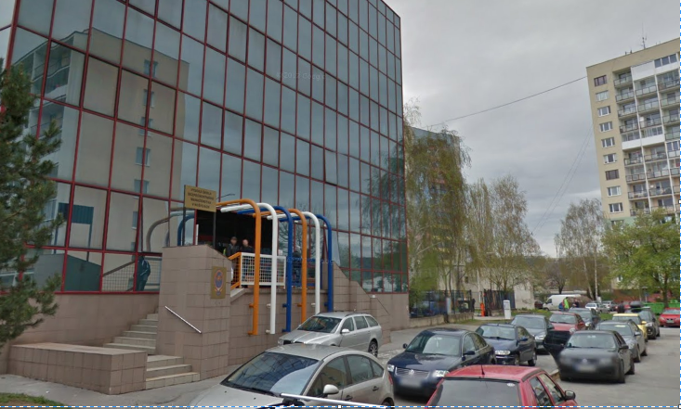
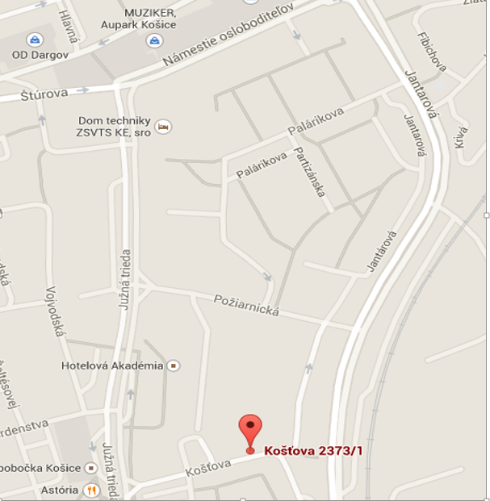
GPS: 48.7108047, 21.2634386

